Bonnington Symbol System
City of Edinburgh Council

Symbol resource 2008

including relevant British Standard symbols from BS 8501


Activities
Catering
College
Environments
Health
Home
People
Self development

activities
measures
training/workshops




The Resource
This resource has been created as a series of word documents which may be printed out to use as a visual reference and index.

Copy and Paste/Instructions
To reproduce an image:
- Single click on the image ensuring it is selected
- Select Copy from the Edit menu (or use keyboard shortcut Ctrl+C)
- Open the document you wish to place the image in (e.g. word document)
- Select Paste from the Edit menu (or use keyboard shortcut Ctrl+V)

Images may be resized by dragging in or out from a corner, images may be resized up to A4 without any loss of quality.

Images may be placed in tables or text boxes.

If you have any difficulty using any of the images please contact BSS using the contact details below.

Acknowledgement British Standards: Permission to reproduce extracts from the BS 8501:2002 is granted by BSI. The British Standards can be obtained from BSI Customer Services, 389 Chiswick High Road, London W4 4AL. Tel +44 (0)20 8996 9001

Acknowledgement BSS Edinburgh Council: Permission to reproduce BSS symbols is granted by The City of Edinburgh Council Health and Social Care; however reproduction of any part of the CD ROM in any form is not permitted.

Disclaimer: The City of Edinburgh Council cannot accept any responsibility for damage caused to your computer or data whilst using this CD.

Contact information: Gordon Fraser, Performance Review Manager. The City Of Edinburgh, Health and Social Care, Waverley Court, 4 Market Street Tel: +44 (0)131 553 8266
www.edinburgh.gov.uk/internet/social_care/CEC_learning_disability

 |  | 
About you-female  8000 | About you-male  8001 | Agreement  8002
 | 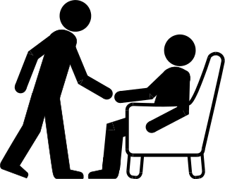 | 
Appropriate clothing  8003 | Being helpful  8004 | Being polite  8005
 |  | 
Best thing  8006 | Body awareness  8007 | Budgeting  8008
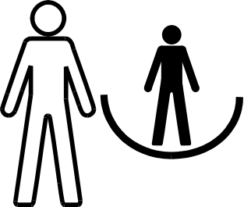 |  | 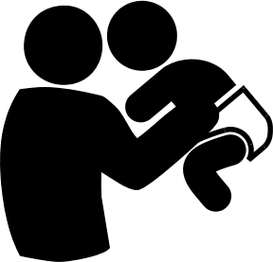
Care and support  8009 | Carer’s voice  8010 | Child care  8011
Bonnington Symbol System
www.edinburgh.gov.uk
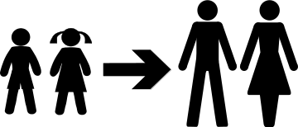 |  | 
Child to adult  8012 | Children  8013 | Choices  8014
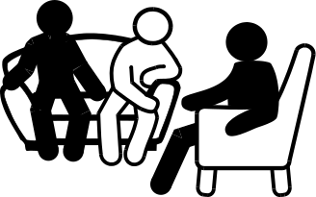 |  | 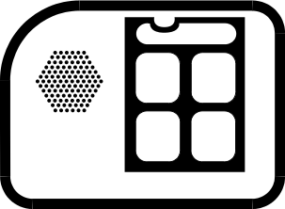
Comfy group  8015 | Communication  8016 | Communication aid  8017
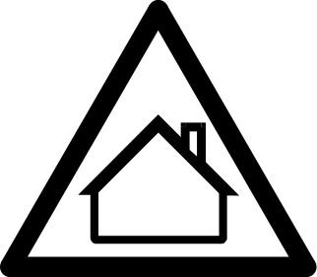 | 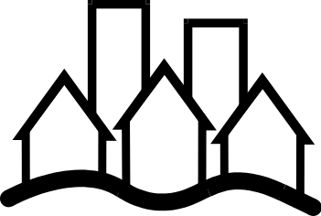 | 
Community safety  8018 | Community use  8019 | Confidential information  8020
 |  | 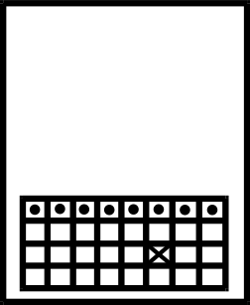
Consulting figures  8021  Bonnington Symbol System  www.edinburgh.gov.uk | Crowd  8022 | Date  8023
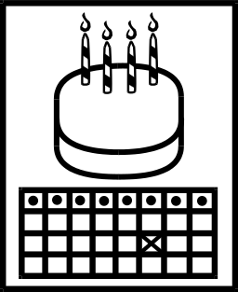 |  | 
Date of birth  8024 | Day centre  8025 | Day time  8026
 | 
Don’t clown  8027 | Feeling good-female  8028 | Feeling good-male  8029
 |  | 
Feelings  8030 | Friend  8031 | Going away somewhere  8032
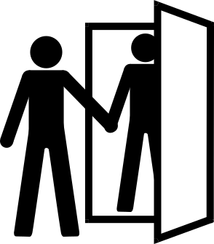 | 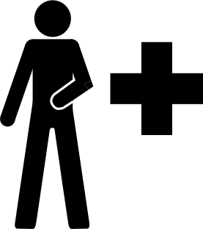 | 
Having visitors  8033  Bonnington Symbol System  www.edinburgh.gov.uk | Health #1  8034 | Health #2  8035
  Bonnington Symbol System  www.edinburgh.gov.uk |  | 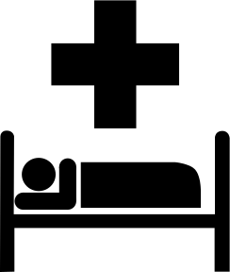
Home  8036 | Home diary  8037 | Hospital  BS 8501 6016
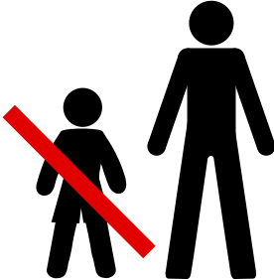 | 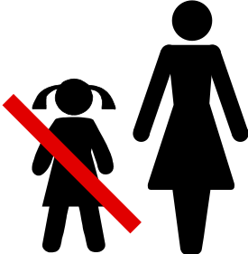
Independence-man not boy  8038 | Independence-woman not girl  8039 | Information  BS 8501 6001
 | 
Interview  8040 | Keeping quiet  8041 | Living safely  8042
 |  | 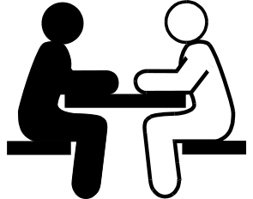
Magic wand  8043 | Man  8044 | Meeting  8045
Bonnington Symbol System
www.edinburgh.gov.uk

 |  | 
Meeting-planning meeting  8046 | Meeting-to discuss things  8047 | Mobile phone  8048
 | 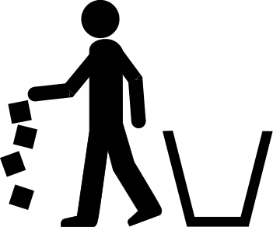 | 
Night time  8049 | Not doing the job  8050 | Paid worker  8051
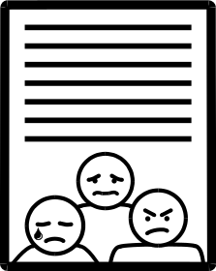 | 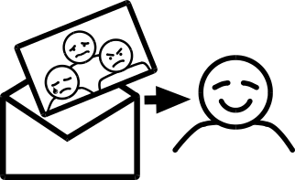 | 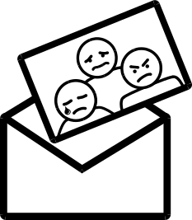
Paperwork-complaint form  8052 | Paperwork-complaint form result  8053 | Paperwork-complaint form sending  8054
 |  | 
Paperwork-list to do  8055 | Paperwork-notes  8056 | Paperwork-notes from your meeting  8057
Bonnington Symbol System
www.edinburgh.gov.uk

 |  | 
Paperwork-risk assessment  8058 | Paperwork-sending a letter  8059 | Paperwork-task list  8060
 |  | 
Questions  8061 | Religion  8062 | Respite  8063
 | 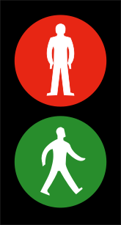 | 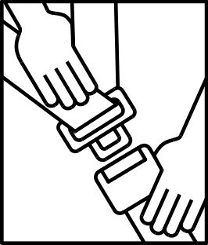
Risk  8064 | Road safety  8065 | Safe care and restraint  8066
 |  | 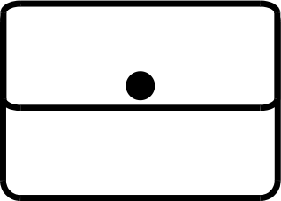
Saying what you think  8067 | Scottish Executive publication  8068 | Self care-care of belongings  8069
Bonnington Symbol System
www.edinburgh.gov.uk

 |  | 
Self care-care of glasses  8070 | Self care-care of your money  8071 | Self care-cleaning teeth  8072
 | 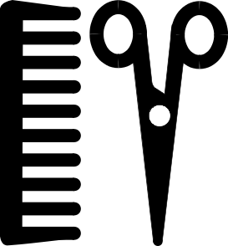 | 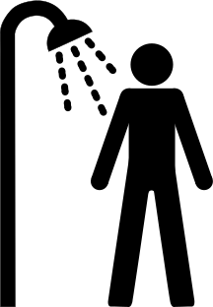
Self care-eating well 8073 | Self care-hair  BS 8501 6014 | Self care-keeping clean  8074
 | 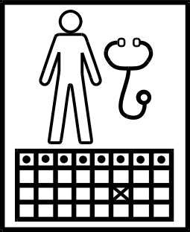 | 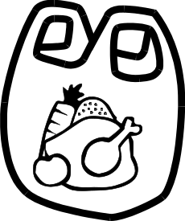
Self care-keeping safe  8075 | Self care-making Doctor appointment  8076 | Self care-shopping for food  8077
 |  | 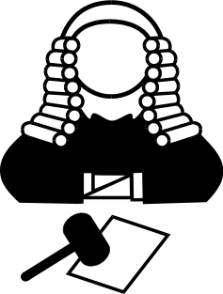
Self care-washing clothes  8078  Bonnington Symbol System  www.edinburgh.gov.uk | Self care-looking after your health  8079 | Sheriff  8080

 |  | 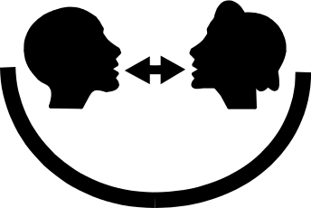
Signing  8081 | Signing your name  8082 | Supported communication  8083
 |  | 
Support-extra support  8084 | Support-in your own home  8085 | Symbols  8086
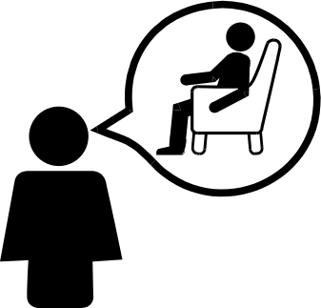 | 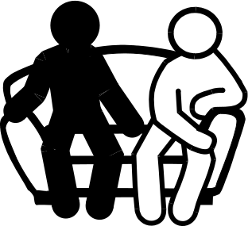
Talking about other people  8087 | Talking informally  8088 | Talking to others  8089
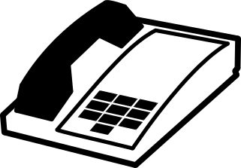 |  | 
Telephone-alternative  8090 | Telephone  BS 8501 6003 | Telephone call  8091
Bonnington Symbol System
www.edinburgh.gov.uk

 |  | 
Things at home okay  8092 | Things you are good at  8093 | Things you need help with  8094
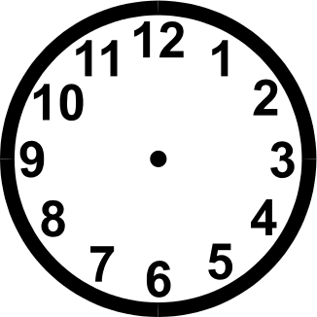 | 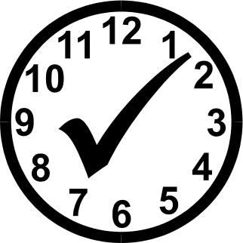 | 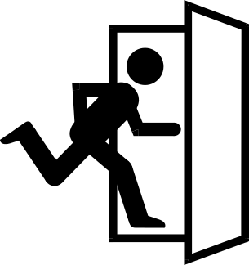
Time  8095 | Timekeeping-be on time  8096 | Timekeeping-hurry to leave  8097
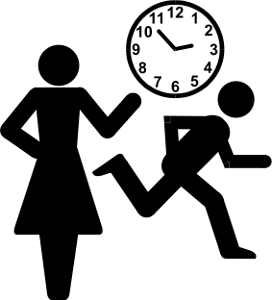 |  | 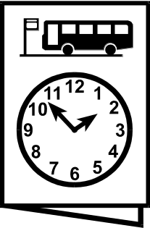
Timekeeping-late  8098 | Transport-bus pass  8099 | Transport-bus timetable  8100
 |  | 
Transport-go out in car  8101 | Transport- organised  8102 | Transport-public #1  8103
Bonnington Symbol System
www.edinburgh.gov.uk

 |  | 
Transport-public #2  8104 | Transport-using taxi #1  BS 8501 7007 | Transport-using taxi #2  8105
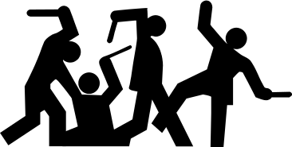 | 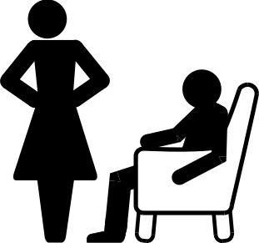
Trouble  8106 | Unfriendly  8107 | Visitor to your house  8108
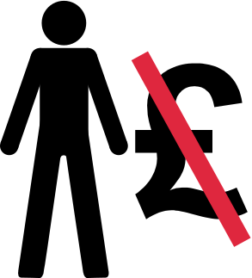 |  | 
Volunteer  8109 | Voting  8110 | Woman  8111
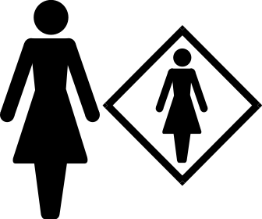 |  | 
Woman’s rights  8112 | Work #1  8113 | Work #2  8114
Bonnington Symbol System
www.edinburgh.gov.uk

 |  | 
Work placement  8115 | Work support  8116 | Work-job preparation  8117
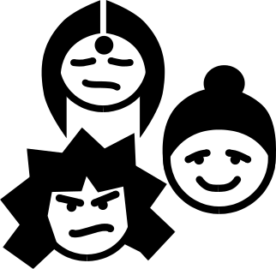 | 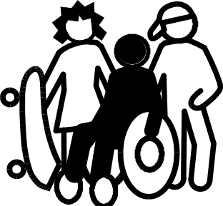 | 
Young people #1  8118 | Young people #2  8119 | Your community  8120

Your thoughts
8121

Bonnington Symbol System
www.edinburgh.gov.uk

Bonnington Symbol System
www.edinburgh.gov.uk

